SO for approximation technique one of the best algorithm is Lloyd’s Algo.

The first step in determining centeroids is “Initialization” i.e. we need to pick k random points of d dimension where k is number of clusters and d in dimension.

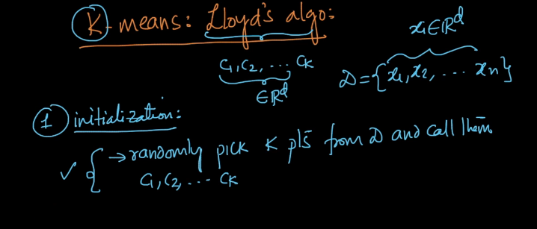

And it is called random initialization.

Second stage is called as assignment stage.

In this stage we find the nearest centroid for each point and assign it to the set for which the distance is minimum.

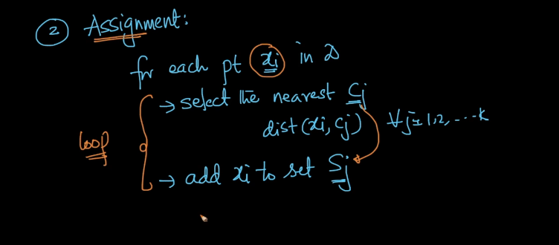

Third step is updating centroid by taking mean of every cluster Sj as shown in fig below.

And this is to be done by every C i.e. C1,C2,C3,….,Ck.

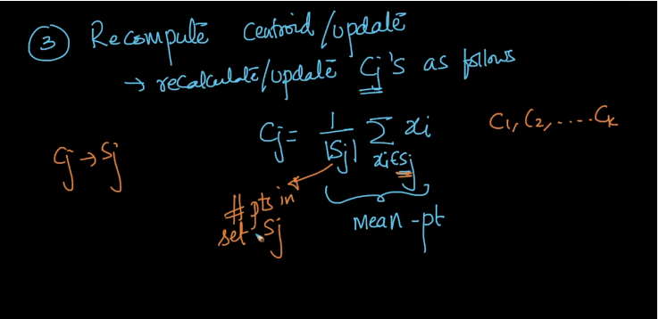

Now we repeat step 2 and 3 until we get a convergence point i.e. till we get minimal difference between old centroids and updated centroids, i.e. {C1-C1! , C2-C2!, …,Ck-Ck!} is small.

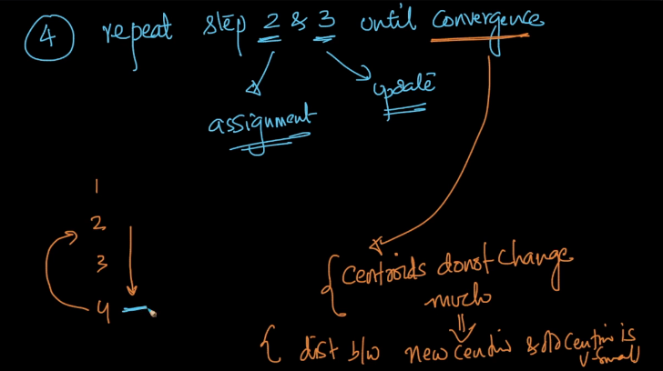

**Comments:**

